|  |  |
| --- | --- |
|  | **Nutri Bliss**  **E-Commerce**  **(Technical Design Document)** |
| |  |  |  |  | | --- | --- | --- | --- | |  | **Prepared By / Last Updated By** | **Reviewed By** | **Approved By** | | **Name** | Bhargey Kaneriya |  |  | | **Role** | Programmer Analyst  Trainee |  |  | | **Signature** | Bhargey Kaneriya |  |  | | **Date** | 20-02-2024 |  |  | |
|  |

Table of Contents

1.0 Introduction 3

1.1 Purpose of this document 3

1.2 Project overview 3

2.0 Solution Summary 3

2.1 Scope 3

2.2 Assumptions 3

2.3 Dependencies 3

2.4 Risks 3

3.0 Schematic Diagram 3

4.0 System Design 4

4.1 Proposed design 4

4.2 Component inventory 4

5.0 Database Design 4

5.1 Data Model 4

5.2 Tables Structure 4

6.0 Appendices 4

6.1 Glossary 4

6.2 Other 5

7.0 Terms & Conditions 5

8.0 Change Log 5

# Introduction

## Purpose of this document

The purpose of this document is to document the technical design, component details and Database design. This will also capture the scope, assumptions, risk, dependencies of this project.

## Project overview

The e-commerce platform is a web-based application that serves as a centralized platform for customers looking for health and fitness products. The platform will cater to three specific categories: underweight, overweight, and muscle gain. The products offered will include ready-made smoothies, powders, and other natural products to help customers achieve their fitness goals. Here are some key components of such a system:

1. **User Interface**: This is the front-end of the application where customers interact with the system. It should be user-friendly and easily navigable.
2. **Product Listing Module**: This module allows the platform to display products. The system should be able to capture all necessary details about the product, such as product description, nutritional information, price, etc.
3. **Shopping Cart and Checkout Module:** This module allows customers to select products, add them to a shopping cart, and proceed to checkout. Users should be able to view the details of their cart and the status of their orders.
4. **Admin Dashboard:** This module is responsible for managing the data related to product listings and orders. It can be used by the platform administrators to track the number of orders, manage product listings, etc.
5. **Database**: This is where all the data related to the product listings, orders, and blogs is stored. It should be secure to protect sensitive information.

# Solution Summary

## Scope

**2.1 Product Listing System**

A user-friendly interface for administrators to list products. The system will collect necessary information about the product, such as product description, nutritional information, price, and any other relevant details.

**2.2 Shopping Cart and Checkout System**

A robust system that allows customers to select products, add them to a shopping cart, and proceed to checkout. This includes updates on the order process and delivery status.

**2.3 Management System**

A management system for administrators to manage product listings and orders. This includes features for product listing, order tracking, and more.

**2.4 Data Security**

Ensuring the security of sensitive data is paramount. The system will incorporate state-of-the-art security measures to protect the confidentiality and integrity of data.

## Assumptions

* **Market Demand:** There is a significant demand for online fitness supplement shopping platforms, and this demand will continue to grow in the foreseeable future.
* **Technology Availability:** The necessary technology and infrastructure to develop and maintain an online fitness supplement shopping platform are readily available and accessible.
* **Supplier Reliability:** Suppliers will provide consistent quality of natural products, and they will be able to meet the demand.
* **Delivery Logistics**: Reliable delivery partners are available and can ensure timely delivery of supplements.
* **User Adoption:** Users, both customers and administrators, will adopt and adapt to the new platform quickly.
* **Security Measures:** Robust security measures will be sufficient to protect sensitive customer data and prevent cyber threats, data breaches, and unauthorized access.
* **Regulatory Compliance:** The platform will comply with all relevant laws and regulations related to online retail and data privacy.
* **Maintenance and Support:** Adequate resources will be allocated for the maintenance and support of the platform post-launch.
* **Pandemic Impact:** The shift towards online retail due to the pandemic will persist even after the pandemic ends.

## Dependencies

* **HTML, CSS, JavaScript, and Bootstrap:** These technologies will be used for front-end development, creating user interfaces, responsive layouts, and consistent styling.
* **Java, Spring Boot, and Hibernate:** These technologies will be used for back-end development, business logic, RESTful APIs, and interacting with the MySQL database.
* **MySQL:** This popular open-source relational database management system will be used for storing and retrieving data efficiently.

## Risks

* **Market Volatility:** Changes in market trends or consumer behavior could affect the demand for online fitness supplement shopping.
* **Technological Challenges:** There could be unforeseen technical issues during the development and maintenance of the platform.
* **Supplier Inconsistency:** Suppliers may fail to provide consistent quality of natural products, or they may not be able to meet the demand.
* Delivery Delays: There could be delays or issues with the delivery logistics, affecting customer satisfaction.
* **Slow User Adoption:** Users, both customers and administrators, may take longer than expected to adopt and adapt to the new platform.
* **Regulatory Changes**: Changes in laws and regulations related to online retail and data privacy could impact the platform’s operations.
* **Maintenance Issues:** There could be challenges in allocating adequate resources for the maintenance and support of the platform post-launch.
* **Pandemic Impact Uncertainty:** The impact of the pandemic on the shift towards online retail is uncertain and could change as the situation evolves.

# Schematic Diagram

**UML:**

UML is language. A language provides a vocabulary and the rules for combining words in that vocabulary for the purpose of communication. A modeling language is a language whose vocabulary and rules focus on the conceptual and physical representation of a system. A modeling language such as UML is thus a physical representation of a system. A modeling language such as UML is thus a standard language for software blueprints.

**CLASS DIAGRAMS:**

A diagram that shows a set of classes, interfaces and collaborations and their relationships, class diagrams address the static view of the system. Diagrams that shows the collection of declarative (static) elements.

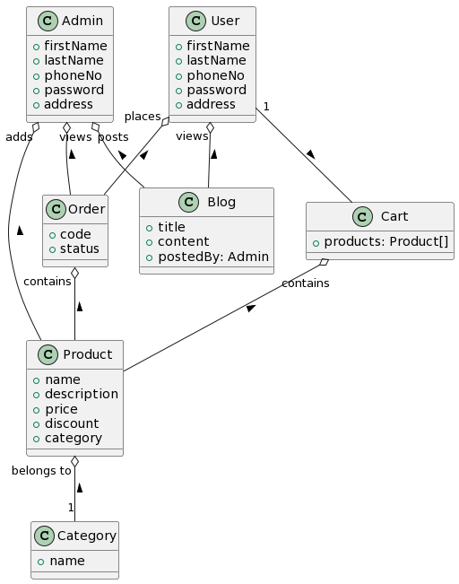

**Figure 1: Class Diagram**

**USECASE DIAGRAMS:**

The use case view includes all of the actors, use case diagrams in the system. It may also include some sequence and collaboration diagrams. The use case view is an implementation independent. It focuses on a high level picture of what the system will do without worrying about the details of how the system will do.

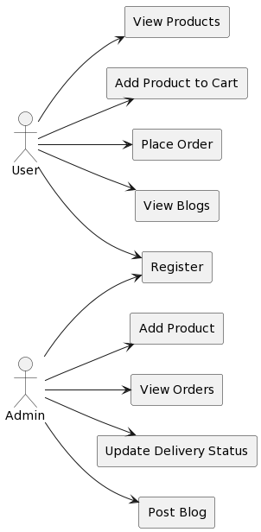

**Figure 3: Use case Diagram**

# System Design

## Proposed design

**Front-end:**

The front-end will provide an interface for users to browse products, add them to the cart, and manage their orders. It will be developed using HTML, CSS, and JavaScript to ensure a responsive and interactive user experience.

**Back-end:**

The Back-end will handle requests from the front-end, perform necessary computations, and interact with the database. It will be developed using Spring Boot, leveraging its simplicity and power for building web applications quickly. It will handle tasks such as user authentication, product listing, order submission, and order management.

**Database:**

The database will store user data, product listings, and order data. It will be designed using MySQL, a popular open-source relational database management system known for its reliability and performance. The database will ensure that all product listings, user profiles, and orders are stored securely and can be retrieved efficiently.

## Component inventory

Component inventory Components for the e-commerce platform include various web pages, API endpoints, and database tables.

**Web Pages:**

* **Home Page** Provides general information about the system and links to other pages.
* **Product Listing Page**: Allows administrators to post product listings.
* **Admin Page:** Allows admins to manage product listings and user accounts.
* **About Page:** Provides information about the company, its mission, and its values.
* **Blog Page**: Allows users to read blog posts about fitness and health, and allows admins to post new blogs.

**Database Tables:**

* **Users**: Stores user data such as user ID, username, password, and role.
* **Products**: Stores product data such as product ID, admin ID, product title, product description, product category, price, etc.
* **Orders**: Stores order data such as order ID, product ID, user ID, order status, etc.
* **Admins**: Stores admin data such as admin ID and user ID.
* **Blogs**: Stores blog data such as blog ID, admin ID, blog title, blog content, etc.

# Database Design

## Data Model

For a E commerce, the data model could include tables for users, admin, orders, and Blog. Each table would include fields relevant to its data. Relationships between tables would be defined using foreign keys.

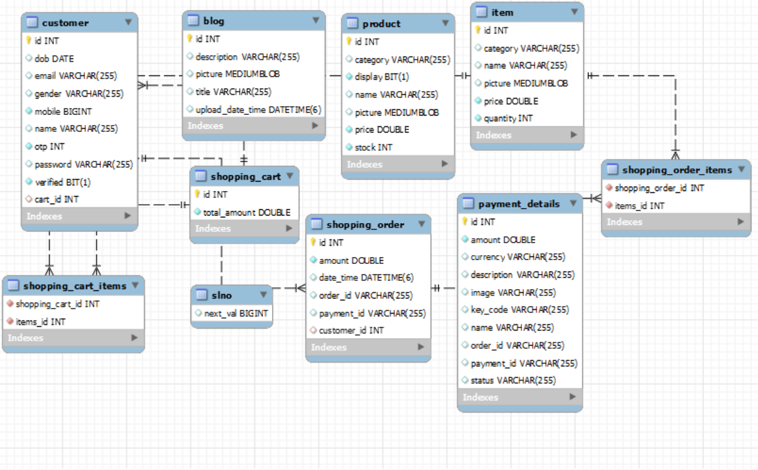

***Figure 6: ENTITY RELATION DIAGRAM***

## Tables Structure

*Here we have the user table for NutriBliss.*

|  |  |  |  |
| --- | --- | --- | --- |
| **Column Name** | **Data Type** | **Length** | **Nulls** |
| user_id | int | 11 | Not null |
| First_name | varchar | 255 | Not null |
| Last_name | varchar | 255 | Not null |
| Mobile_no | varchar | 255 | Not null |
| password | varchar | 255 | Not null |
| email_id | varchar | 255 | Not null |

*Here we have the admin table for NutriBliss.*

|  |  |  |  |
| --- | --- | --- | --- |
| **Column Name** | **Data Type** | **Length** | **Nulls** |
| admin_id | int | 11 | Not null |
| First_name | varchar | 255 | Not null |
| Last_name | varchar | 255 | Not null |
| password | varchar | 255 | Not null |

Here we have the product table for NutriBliss:

|  |  |  |  |
| --- | --- | --- | --- |
| **Column Name** | **Data Type** | **Length** | **Nulls** |
| product_id | int | 11 | Not null |
| category_id | int | 11 | Not null |
| description | varchar | 255 | Not null |
| name | varchar | 255 | Not null |
| price | double | default | Not null |

Here we have the cart table for NutriBliss:

|  |  |  |  |
| --- | --- | --- | --- |
| **Column Name** | **Data Type** | **Length** | **Nulls** |
| cart_id | int | 11 | Not null |
| date | varchar | 255 | Not null |
| product_id | int | 11 | Not null |
| quantity | int | 11 | Not null |
| user_id | int | 11 | Not null |

Here we have the orders table for NutriBliss:

|  |  |  |  |
| --- | --- | --- | --- |
| **Column Name** | **Data Type** | **Length** | **Nulls** |
| orders_id | int | 11 | Not null |
| product_id | int | 11 | Not null |
| order_date | varchar | 255 | Not null |
| order_code | varchar | 255 | Not null |
| quantity | int | 11 | Not null |
| user_id | int | 11 | Not null |

# Appendices

## Glossary

|  |  |
| --- | --- |
| **Acronyms** | **Definitions** |
| HTML | HyperText Markup Language |
| CSS | Cascading Style Sheets |
| JS | Javascript |
| JAVA | A general-purpose, object oriented language |
| SPRING BOOT | A framework for building web apps and service |
| MYSQL | Microsoft’s Relational Database Management System |

## Other

# Terms & Conditions

***Disclaimer: Please do not circulate or distribute this document outside of Cognizant Network, We have a Zero Tolerance Policy. Kindly adhere to 100% Compliance at all times.***

# Change Log

*Please note that this table needs to be maintained even if a Configuration Management tool is used.*

|  |  |  |  |  |
| --- | --- | --- | --- | --- |
| Version Number | Changes made | | | |
| V<n.n> | *<If the change details are not explicitly documented in the table below, reference should be provided here>* | | | |
| Page no | Changed by | Effective date | Changes effected |
|  |  |  |  |
|  |  |  |  |
|  |  |  |  |
|  |  |  |  |